Name: __________________________________ Date: ____________

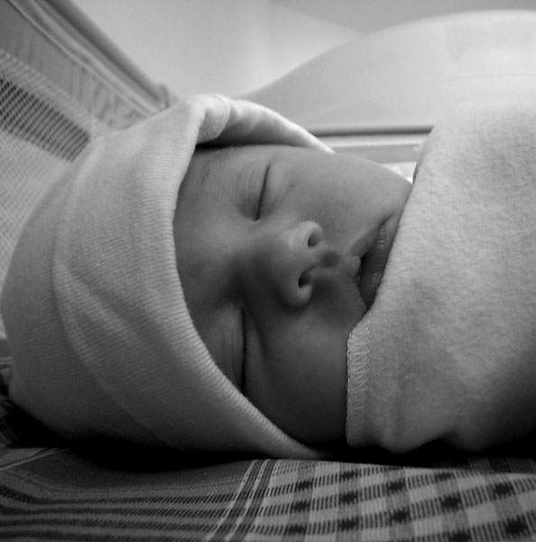

-NICU-
Neonatal Intensive Care Unit

Nursing Core Clinical Skills:
Orientation Booklet for Nurses

General Patient Care
 | Seen  Date | Done with help Date | Done alone Date
- Verification of bedside equipment - SAFE
- Infection Prevention (e.g. hand hygiene, precautions, scrub the hub, etc.)
- Admission routine
- Assessment and monitoring of vital signs
- Use of physiologic monitor, including central monitor (limit setting, printing of strip, assigning name, etc.)
- Breast pump set-up and teaching
- Skin, mouth, eyes, bum care
- Bath for preterm, term, including CHG wipe-down
- Prevention of heat loss
- Umbilical line insertion (positioning, materials needed, fluids to run)
- Use of incubator (ISC probe, humidity, dome open vs closed)
- Hyperbilirubinemia & phototherapy
- Weight, length and head circumference
- Kangaroo care
- Discharge – teaching car seat safety, Dodo sur le dos, Shaken Baby Syndrome, medication administration
- Charting (nursing and medical chart)
- Care plans based on gestational age
- Pre-op care
- Post-op care
- Rounds – Giving report by system, major concerns
- Internal transport to tests (eg. MRI, PICC line, upper GI, VCUG, etc)
- Transfers to wards or referring hospital
- Tidying up & organization at bedside
- End-of-life / Palliative / Post-mortem care

Developmental & Family Centered Care
 |  | Seen  Date |  | Done with help Date | Done alone Date
 | - Developmental care – light cycling, noise levels
 | - Developmental care – positioning for preterm, term, post-term (see back of care plans)
 | - Book for Babies, language passport
 | - NeoConnect (Voice recorders, tablets)
 | - Music therapy consults / PT and OT consults

Extreme Prematurity
 |  | Seen  Date |  | Done with help Date | Done alone Date
 | - Admission of the extremely premature baby (< 29 weeks) – Golden Hour
 | - Temperature regulation (incubator, warming lamp, warming mattress, warmed blankets, humidity)
 | - Handling, positioning, and clustering of care
 | - IVH & IVH prevention
 | - Skin care (Mepitac or silicone tape only, rinsing of CHG, etc)

Respiratory and cardiovascular management
 | Seen  Date | Done with help Date | Done alone Date
- Respiratory assessment (auscultation, retractions, RR, etc.)
- Oxygen needs - OWL protocol
- Flow-inflating bag, blender
- Low flow O2
- High flow O2
- Bubble CPAP
- NIMV
- NAVA
- Intubated patient on conventional ventilation
- Intubated patient on high frequency or JET ventilation
- Desaturation and apnea (cause and what to do)
- Initial steps in resuscitation (MR SOPA)
- Suctioning – inline vs nasal
- Intubation (medication binder, preparation, and administration of meds)
- Extubation
- Nitric Oxide therapy
- Chest tubes
- Surfactant/BLES
- Tracheostomy care (suctioning, tie change, valves, Trilogy ventilator)
- PPHN care (sedation, minimal handling, high FiO2, etc)
- Cardiac assessment (pulse, HR, murmur, precordium, BP, color, etc.)
- Arterial line set up & use (peripheral and UAL)
- Pre vs post ductal saturation
- PGE (indications, side effects, administration)
- Inotropes and line setup
- Pacer wires
- Congenital heart defects – duct dependent for pulmonary blood flow (eg. TGA, pulmonary atresia, etc)
- Congenital heart defects – duct dependent for systemic blood flow (eg. Coarctation of the aorta)
- NIRS (how to set up, what to watch for)
- SVT, adenosine, and cardioversion (defibrillator)

Central nervous system
 | Seen  Date | Done with help Date | Done alone Date
- Neurologic assessment (fontanelle, level of consciousness, muscle tone)
- Pain assessment (sun scale)
- Pain management for needle procedures (Comfort Zone)
- Pain management for post-op or long-term discomfort (pharmacological agents)
- Withdrawal scales – Finnegan & WAT-1
- VP shunts – subgaleal, VP
- External ventricular drain EVD
- aEEG insertion, monitoring, interpretation
- Initiation of therapeutic hypothermia (cooling)
- Maintenance and rewarming
- Seizures – identification, treatment

Fluid management
 | Seen  Date | Done with help Date | Done alone Date
- Fluid order sheet
- Fluid calculation (TFI: ml/kg/day)
- Fluid management (Choice of fluid)
- TPN
- IV equipment (B-Braun pumps)
- PICCs, UVLs (care & monitoring)
- Frequency change of IV tubing
- Mixing new solutions (recipes)
- Starting IVs, monitoring of site (TLC method)
- Blood product transfusions

GI & Feeding
 | Seen  Date | Done with help Date | Done alone Date
- Gastrointestinal assessment (girth, abdomen appearance, bowel sounds, palpation, stool)
- NG/OG insertion & verification
- Feeding by gavage NG/OG – bolus vs continuous, compressing feeds
- NJ/OJ insertion
- Feeding by gavage NJ/OJ – continuous only
- Gastrostomy button
- Direct breastfeeding as goal (transition from gavage to breast); nutritive vs non-nutritive feed at breast
- Pre- and post-weight when initiating breastfeeding
- Bottle feeding (cheek/chin support, side-lying vs upright, green vs other nipples, pacing)
- Different formulas and fortifications
- Feeding schedule – for small babies using grid; rapid progression for bigger babies
- Gastrostomy/GJ tube care
- Gastric drainage – Replogle to SD or LWS
- Stoma care
- Kangaroo pump vs B-Braun pump (change of tubing/bag/syringe)
- Rectal irrigation
- Common gastrointestinal illnesses (NEC, CMPI, TEF, cleft lip/ palate, duodenal atresia, imperforated anus, gastrochisis, omphalocele, hirshsprung, short gut, reflux, inguinal hernia, etc.)
- Genitourinary assessment (urine output)
- Foley insertion and care
- Common genitourinary illnesses (hydronephrosis, renal insufficiency, hypospadias, etc.)

Medication administration
 | Seen  Date | Done with help Date | Done alone Date
- Calculation of drug dosages and drips, and verification using Lexicomp
- Collective orders (NS lock for PIV, Vit K, etc)
- Transcribing order and independent double-verification
- Satellite pharmacy, central pharmacy hours
- CMAR verification on night shift
- Vaccines – administration & documentation (carnet de vaccination, O-Word, CMAR)
- Administration by NG/OG/oral/rectal route
- Administration by IV syringe pump – intermittent meds (eg. antibiotics)
- Administration by IV slow push
- Preparation & administration by IV syringe pump – continuous infusions (sedation, analgesia, inotropes, PGE, insulin, diuretics, etc), including rate changes

Investigations & Procedures
 | Seen  Date | Done with help Date | Done alone Date
- Assisting for X-Ray
- Eye exams & drops
- MRSA/VRE/KPC/COVID swabs
- Capillary blood draw (includes capillary tube & microtainers)
- Venous blood draw
- Glucose monitoring (Accucheck)
- Urine bag
- Blood and urine sampling for Newborn Screening Program (PKU)
- Assisting for lumbar puncture
- Other tests (EKG, cardiac and head ultrasound, sleep study, etc.)

Other
 | Seen  Date | Done with help Date | Done alone Date
- Use of Traceline, Oacis, Weebly
- Logibec and scheduling

Notes

_______________________________________________________________________________________

_______________________________________________________________________________________

_______________________________________________________________________________________

